Stellarium Testing Notes

Context
- Time 3.5 hours.
- Resources Just me.
- Risks New features – check the release notes.
Known buggy areas – check the bug log.
Didn’t bother with any of that.
- Constraints Absence of oracles.
- Objectives To see if I can do anything useful with an application that appears to be largely untestable.
- Application size Large
- Application complexity High
- Domain knowledge Almost none.
- Application knowledge None

Inventory
What are the sort of things we could test?
I rapidly concluded that in the absence of oracles I could not verify the accuracy of almost anything. However, I could look for inconsistencies, rendering errors and data entry issues.
I could also verify that solar eclipses occur at times that other sources say they did or will.

Types of testing
- Appearance and interaction
- Input constraint and data validation

Notes
- Tested on TM151 - Windows 8 (64-bit) with 23” touchscreen. 3.3GHz Intel i3, 4GB RAM.
- Installed Stellarium v0.13.1
- I am having a great deal of difficulty describing what I am doing in order to track coverage and report issues. I never really found an answer to this.
- Started by just trying to work out what all the controls do.

Location
14/12/2014 15:56:26
- Did some basic tests on Location search. It seems to correctly search for letters, numbers and symbols but there are some minor data issues such as alternate spellings e.g. Almeria and Almería – only one appears in the results depending on whether the ‘i’ is accented or not.
- Scrolled through the list of locations looking for anything interesting such as symbols and diacritics. A tooltip says that location names do not contain diacritics. However, I saw one name that did, so I searched for that character (ä) and found two more locations. These locations are not found unless the search term includes that character.
- Checked that the search is not case-sensitive – it is not.
- Question: how would you find all the locations that contain diacritics? How can we extract the list of locations? I can’t find a way to view the .cat data files at
C:\Program Files\Stellarium\stars\default.
- Clicked on random places on the map to see what locations were listed. Most were sensible but one revealed a data error – a spurious location in India.
- Changed location to Mercury and looked at the stars. There were a couple of elliptical shapes that turned out to be the rings of Saturn. They disappear suddenly as the magnification level is increased. I have no idea why.

Find Object
12/14/2014 5:35:15 PM
- Decided to test the Find functionality by searching for known matches. This mostly worked ok but there were some anomalies such as seeing a close match but not being able to find it using a better match. Also some symbols were matched when they should not be.

Eclipse of the Sun
- One of the few things we can verify is the behavior at the next expected eclipse of the Sun, which is due on 20 March 2015. It is only a partial eclipse in the UK and more southerly latitudes – a full eclipse is only seen near the North pole.
- Also verified the eclipses on 02 August 1133 and 28 July 1851.
- Checked the eclipse of 27 January 632. It occurred but the Sun and Moon became severely egg-shape at the peak of the eclipse.
- Question: How might we find when an eclipse is going to happen?
- Could not verify the eclipse that apparently occurred on October 22, 2134 B.C.E (see http://www.timeanddate.com/eclipse/solar-eclipse-history.html) – there is a near eclipse on the 28th but it’s not even close on the 22nd.
- Also could not verify the eclipse on 14 December 1 BC ) see http://en.wikipedia.org/wiki/List_of_solar_eclipses_in_the_1st_century_BC) – there is a close one on the 26th.
- Also could not verify the eclipse on 19 July 1 BC – there is a close one on the 31st.

Issues
- The labels and icons for deep sky objects appear at different zoom levels so there are sometimes icons with no labels. This may be intentional.
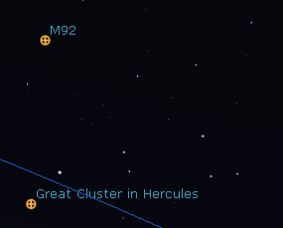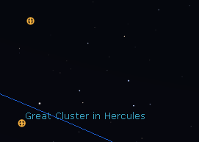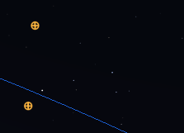
- When viewing from the moon I found that almost everything disappeared when making a slight change to the zoom level.
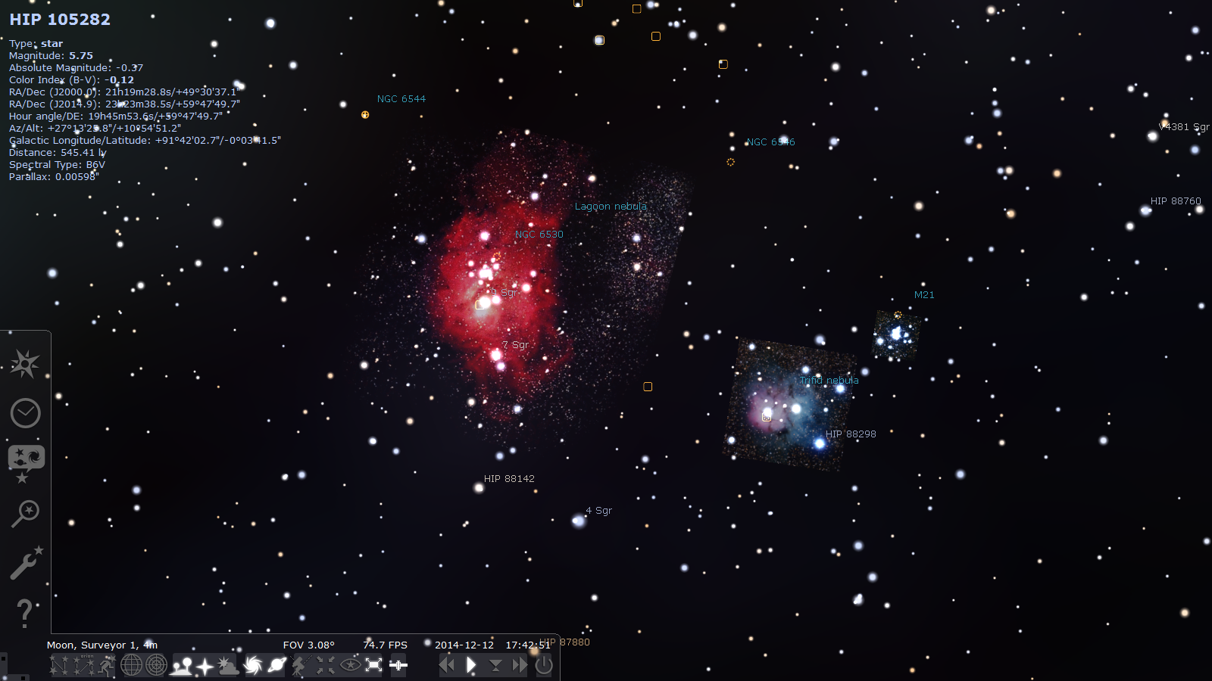
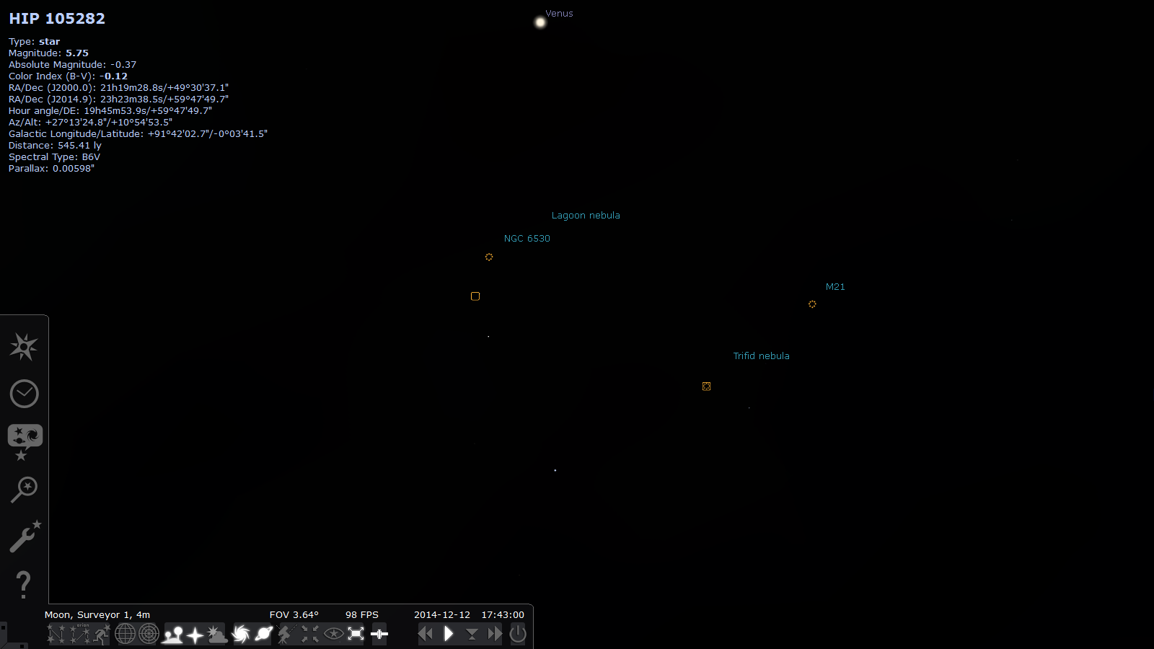

The two nebulae are actually images – there is a folder full of them at
C:\Program Files\Stellarium\nebulae\default. These two are m8bousquet.png and m20-trev.png
- The Location list is not supposed to contain names with diacritics but it does. The locations are not found unless the diacritics are used in the search.
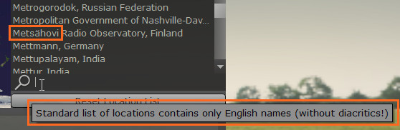
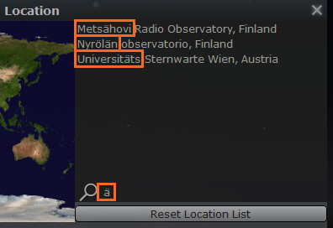
- The list of locations contains an erroneous entry – Indian Astronomical Observatory, Indonesia. The item above it (Indian Astronomical Observatory, India) is correct. Both are shown in exactly the same location on the map.
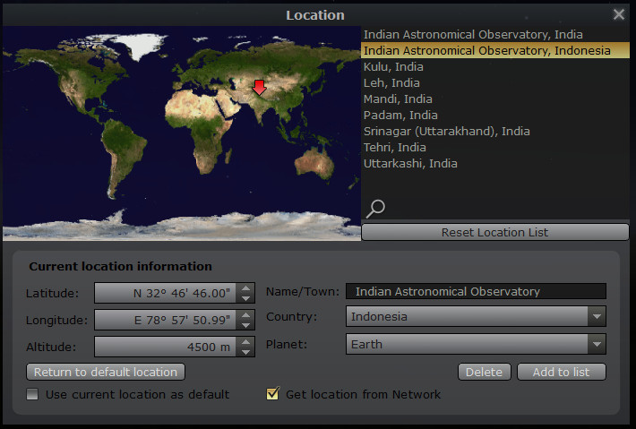
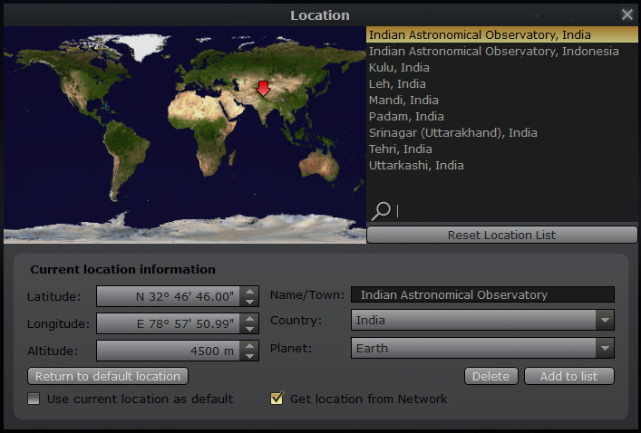
- When looking from Mercury at a star called Alioth there were a couple of elliptical shapes that turned out to be the rings of Saturn. They disappear suddenly as the magnification level is increased. I have no idea why.
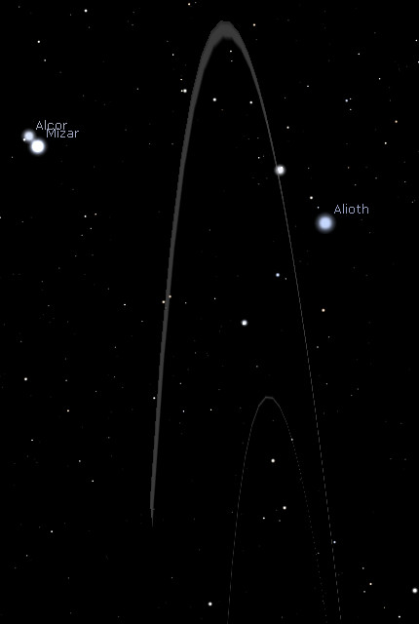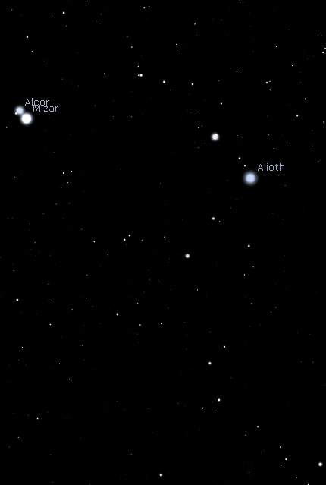
- The information about objects can disappear in night mode. In ‘normal’ mode the text is displayed in black text when the background is light, and lilac text when the background is dark. However, in night mode the text changes colour depending on what the background colour would be in ‘normal’ mode even though the background is always black. As a result the text disappears when the background would be light in ‘normal’ mode.
In the screenshots below, the text colour changes between lilac and black as the sky rotates.
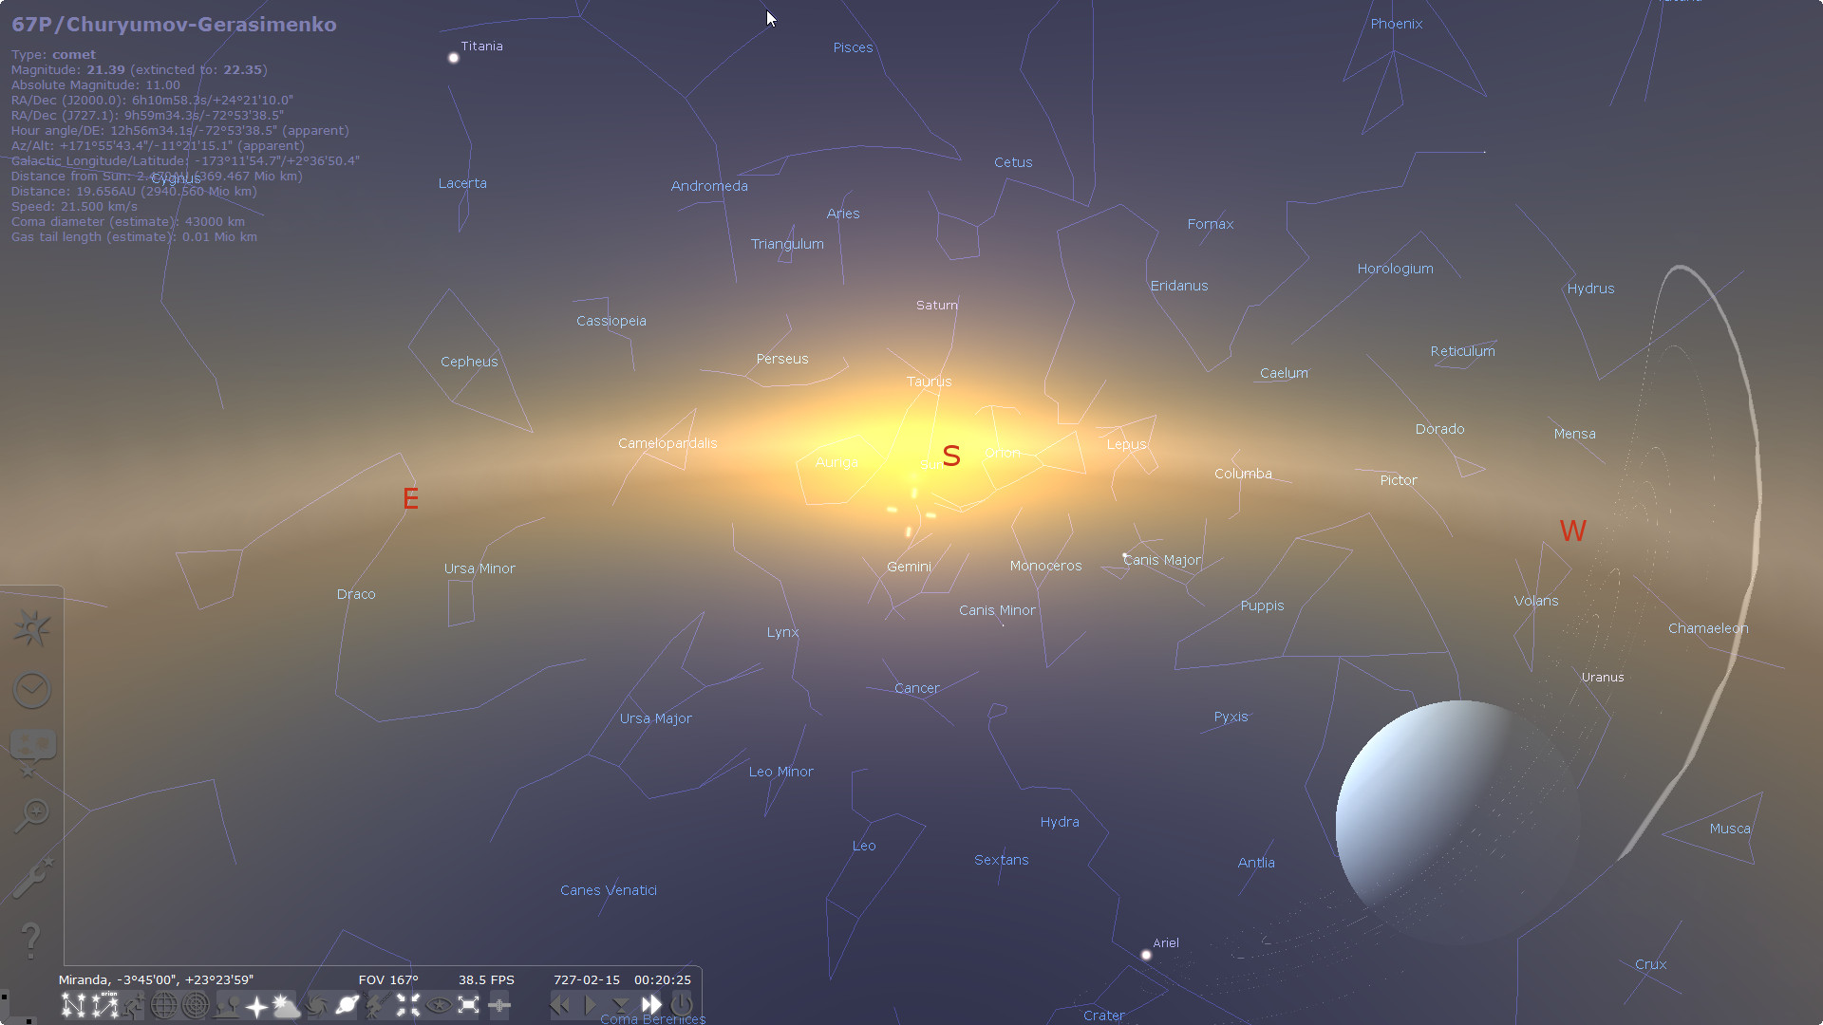
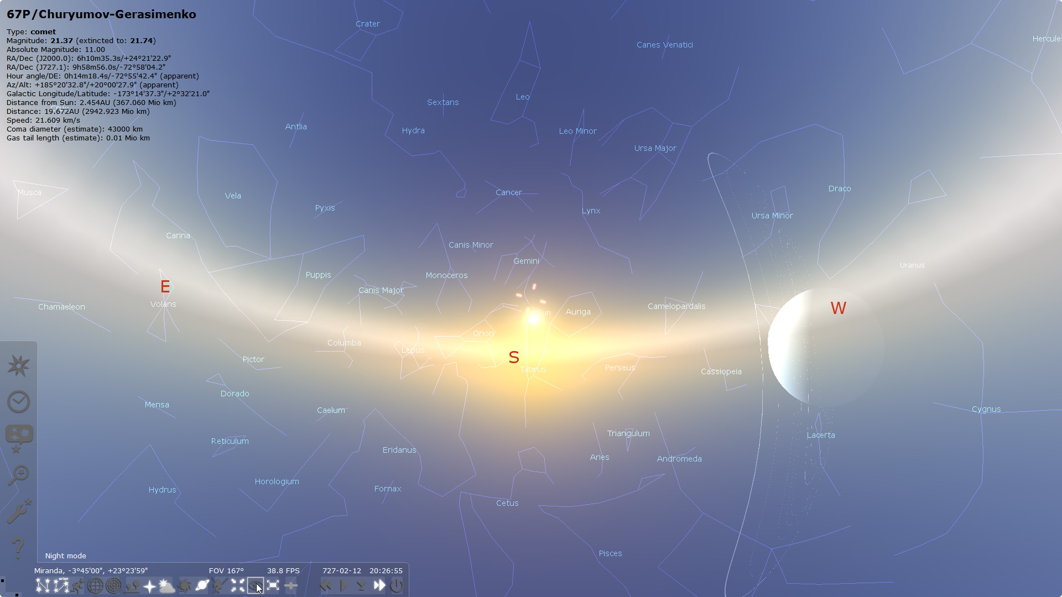
In the screenshots below, the text colour changes between red and black as the sky rotates.
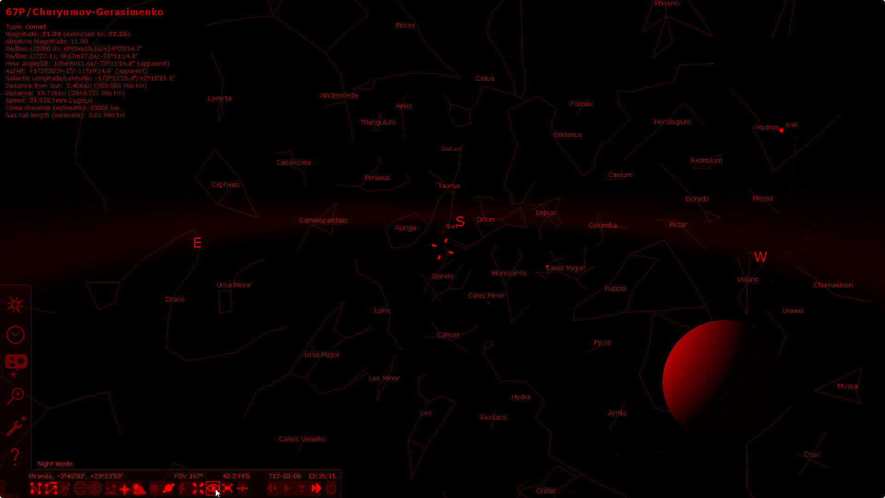
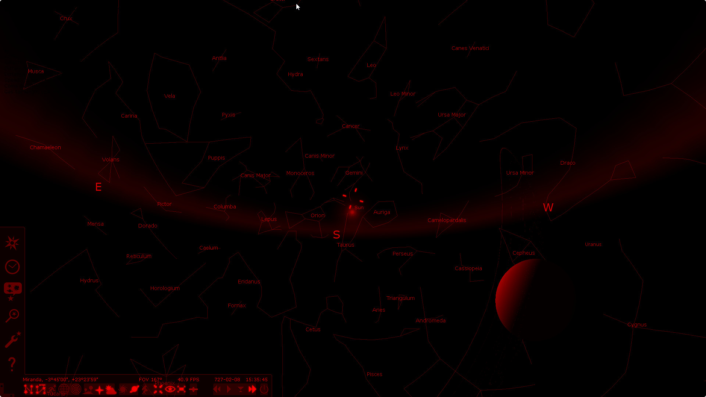
- An object called V* V512 Aur is shown as a suggested match for ‘ste’ for no apparent reason. However, this object is not listed when searching for ‘v*’ or ‘512’ or ‘aur’.
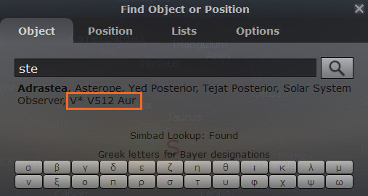
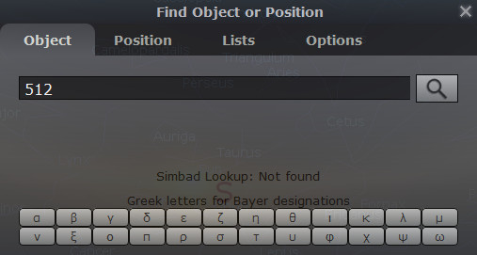
- Erroneous matches are found when the search term includes some symbols. The first screenshot shows some of the results for ‘aur’.
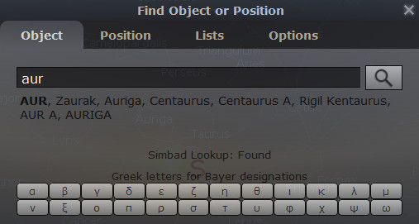
The next two screenshots show the results when a semi-colon and a hash symbol are added to the search term. No results should be found but two results are listed.
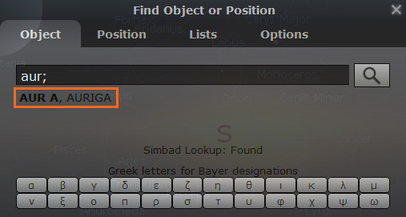
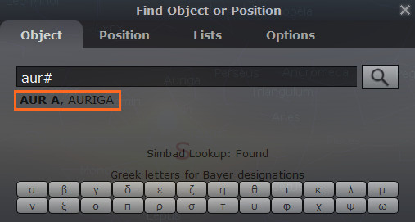

When a pipe symbol is added, the results are inexplicable.
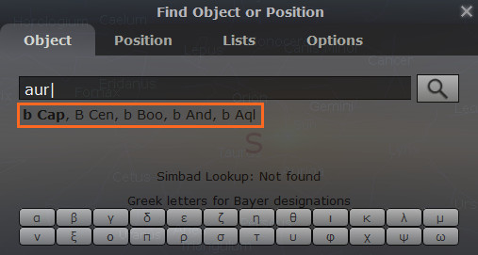
However, a hash symbol on its own returns no matches.
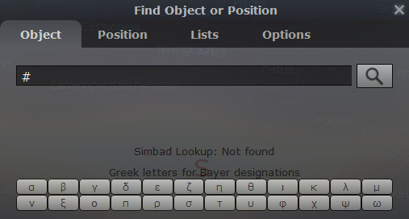
- The Sun and Moon became severely egg-shaped at the peak of the eclipse of 27 January 632.
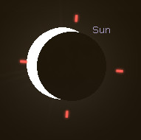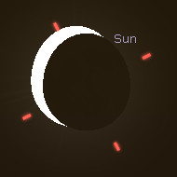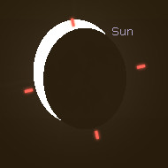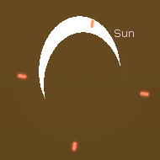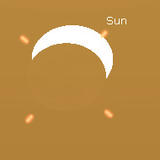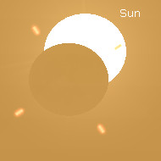
- Could not observe any of the solar eclipses that are supposed to have happened before 1AD. The two I checked in 1BC are both 12 days from when they are supposed to be.

